**Changing Plot Properties**

You can add a title to the plot, set the figure width and height, change title font, etc. Below is a summary of properties which can be added to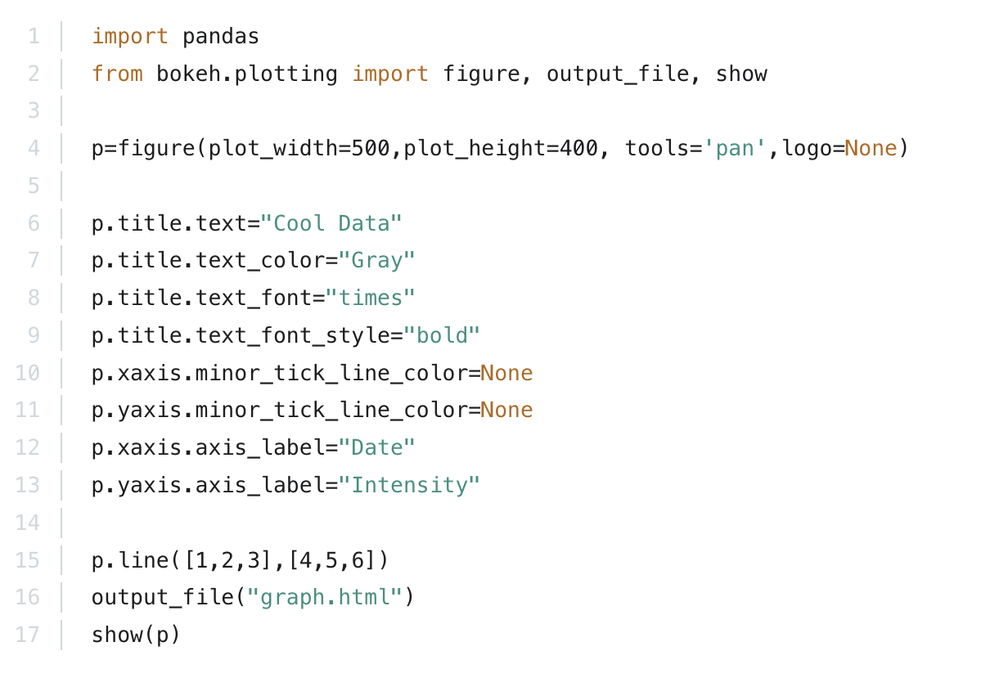 change the style of the plot: